**Lab 11: Introduction to Object Oriented Programming**

**Programming Exercise:**

**Task 01:**

**Class:**

A Class is a code template for creating objects.

**Objects:**

An object is a component of a program that know how to perform certain actions and how to interact with other elements of the program.

**Task 03:**

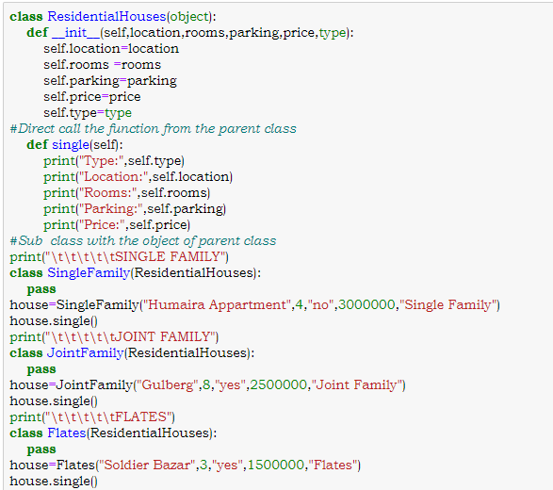

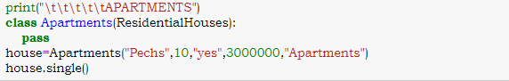

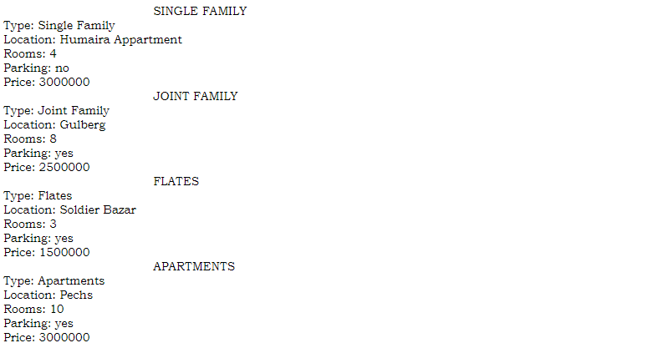

**Task 04:**

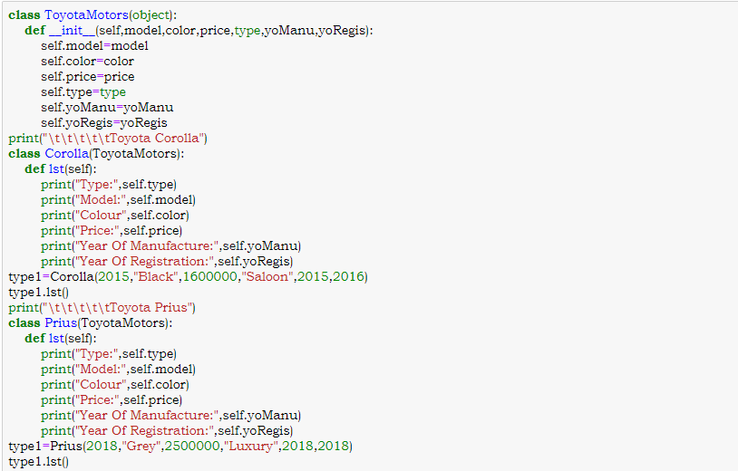

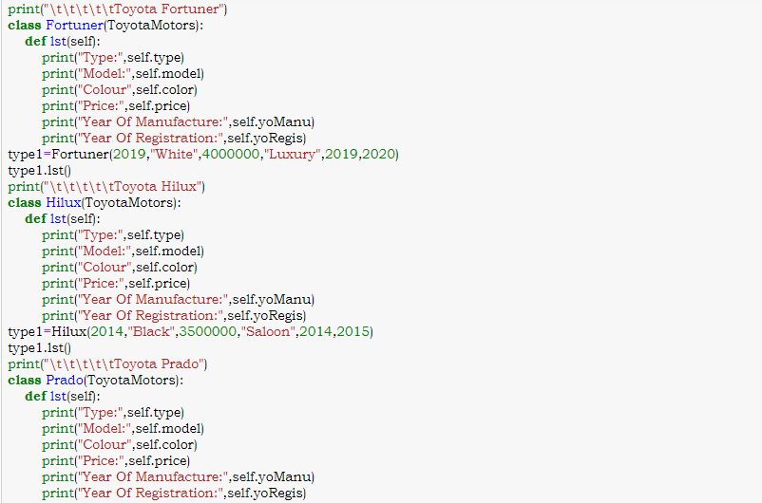

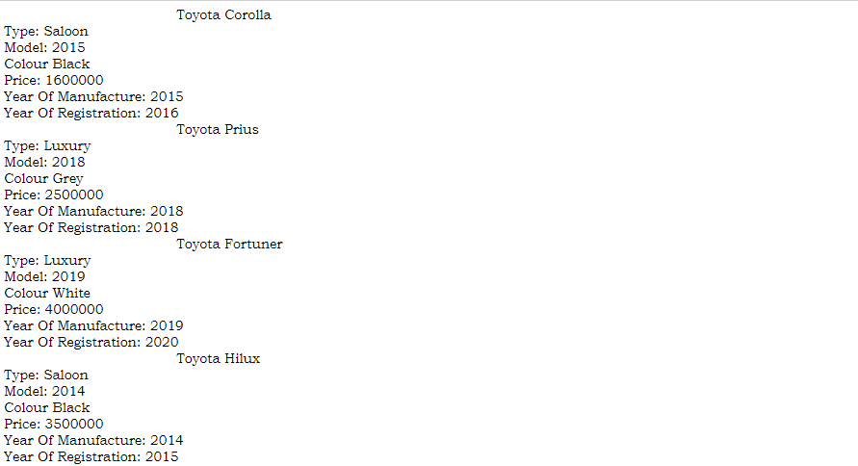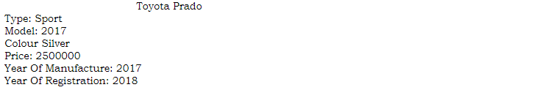

**Task 05:**

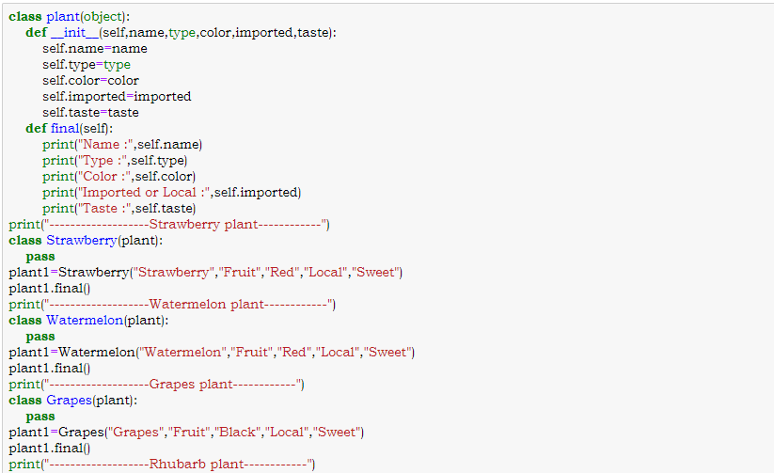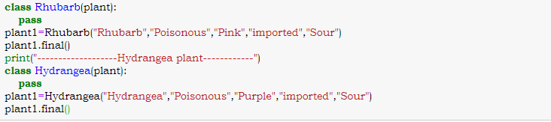

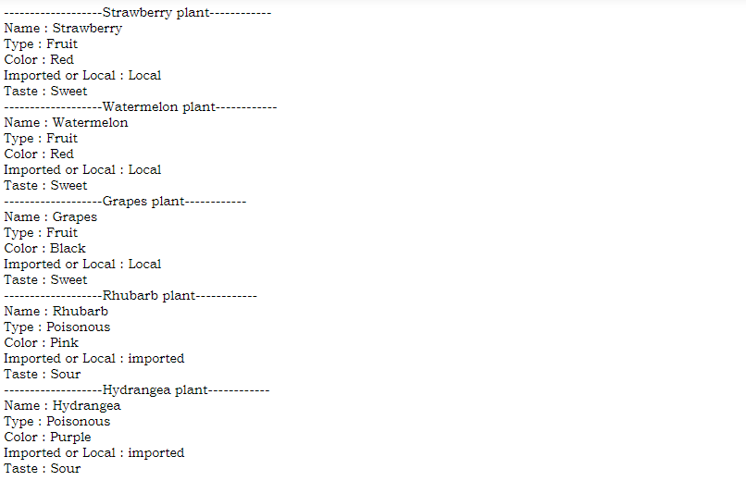

**Task 06:**

